Group 13

Author: 刘承奇

Software  
Requirements

Huarong Path

Table of Contents

System Objective 2

Domain Analysis 2

System Architecture 3

Use Cases 4

Passing Message Analysis 5

Software Requirements 7

R1: Game UI 7

## System Objective

In this project, we are developing a Huarong Path game software. By providing interconnected interfaces to player and chess pieces, the player can play Huarong Path in any initial state he wants, and know whether he wins finally. The system can record the number of operations to help the player achieve better performance. This makes it easier for players to challenge higher scores.

The game is convenient for players. The players can customize the beginning of the game and place the chess pieces whatever they want, or choose from any of the nine set beginnings to play. The game also supports the function of resetting chess piece.

The chess pieces use the ink painting style, has certain considerable appreciation.

## Domain Analysis

The participant of activities in a Huarong Path game can be categorized into Player.

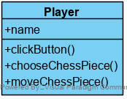

Here is the sequence of events for a player to play the game:

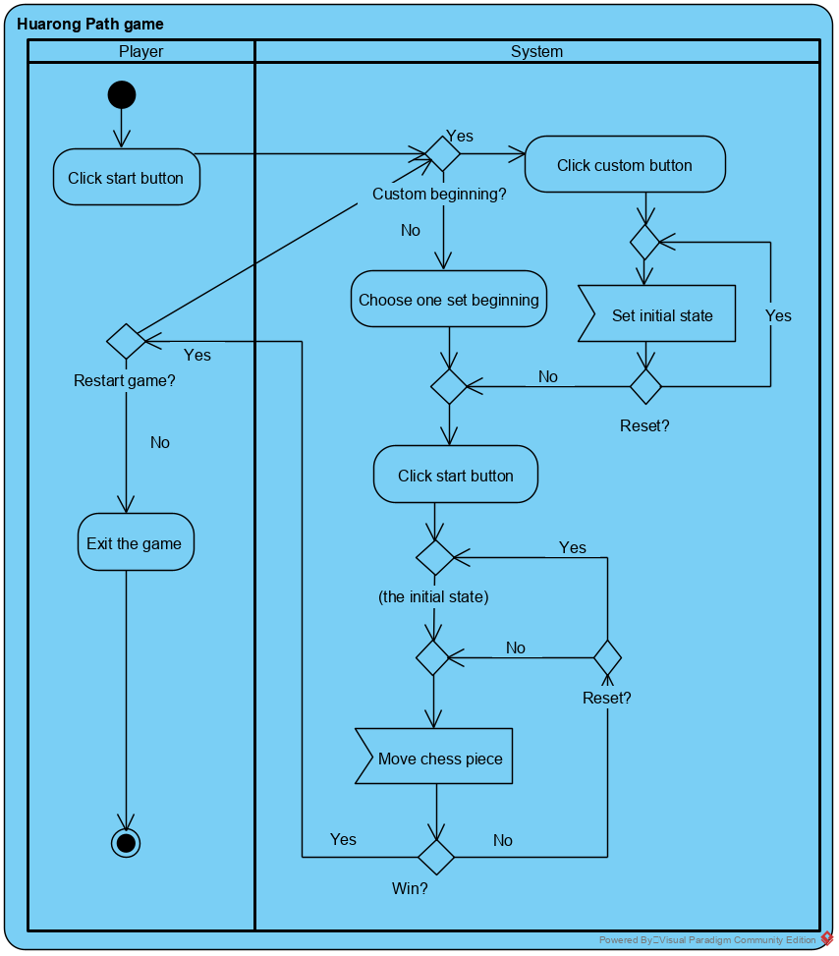

## System Architecture

From the information above, we design a software system with 4 user interfaces: mainMenu, mainInterface, selMenu and WinWindow. mainMenu is the main menu of the game. mainInterface is the UI for moving chess and playing the game. selMenu is the UI for custom beginning. WinWindow is the UI that only appears after the player wins the game. It asks whether the player want to play again.

These interfaces realize many interactions between players and the game. The players can clearly know the current state of the game and the next action that can be performed.

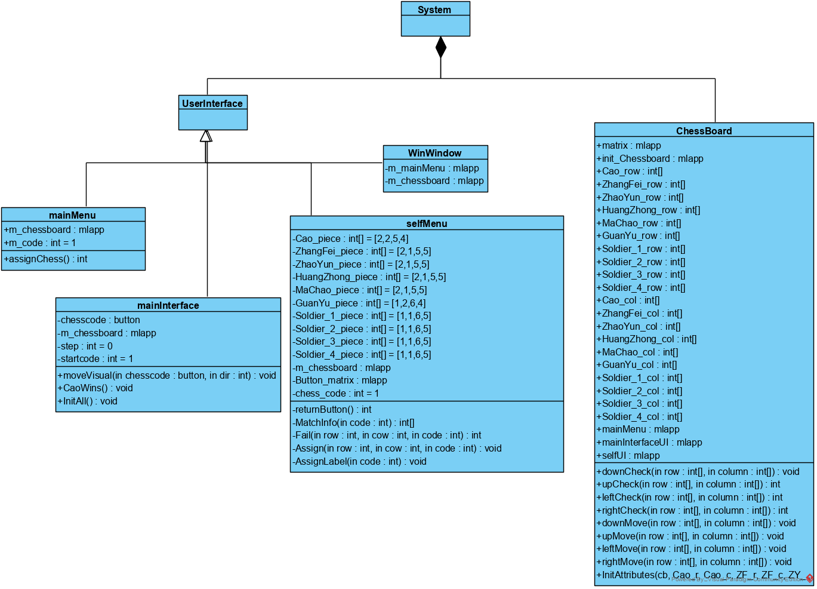

Here are some of the relationships between the classes and functions:

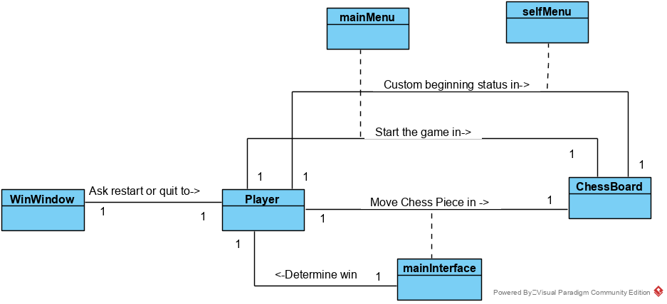

## Use Cases

The system can achieve the following use cases from the Player’s perspectives in the mianInterface:

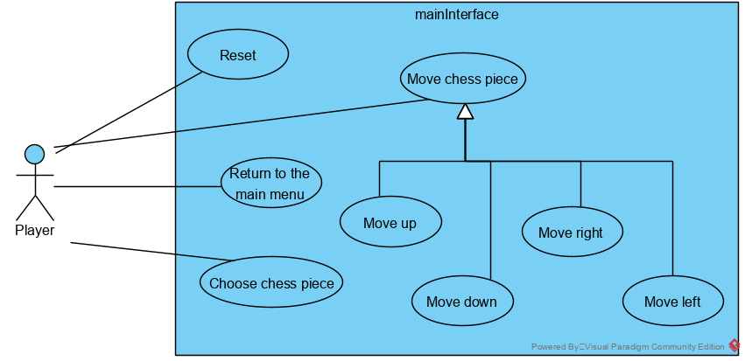

Similarly, in the selfMenu:

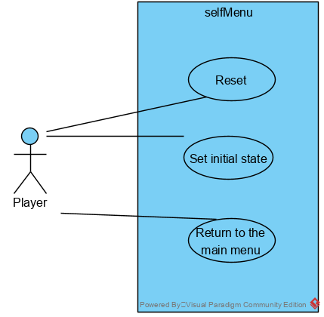

In the mainMenu:

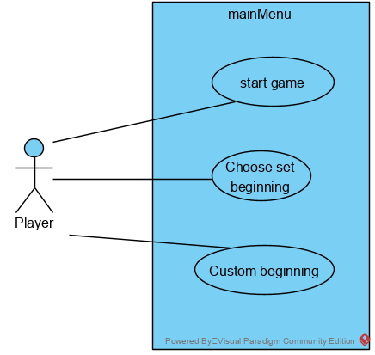

In the WinWindow:

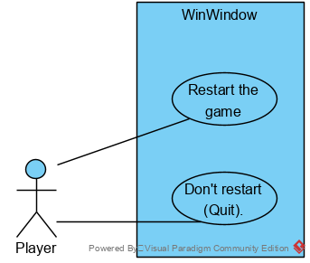

## Passing Message Analysis

The communication between player and the system is shown as follows:

(For simplicity, assume that the player plays Huarong Road only once and don't choose to reset while costuming the beginning.)

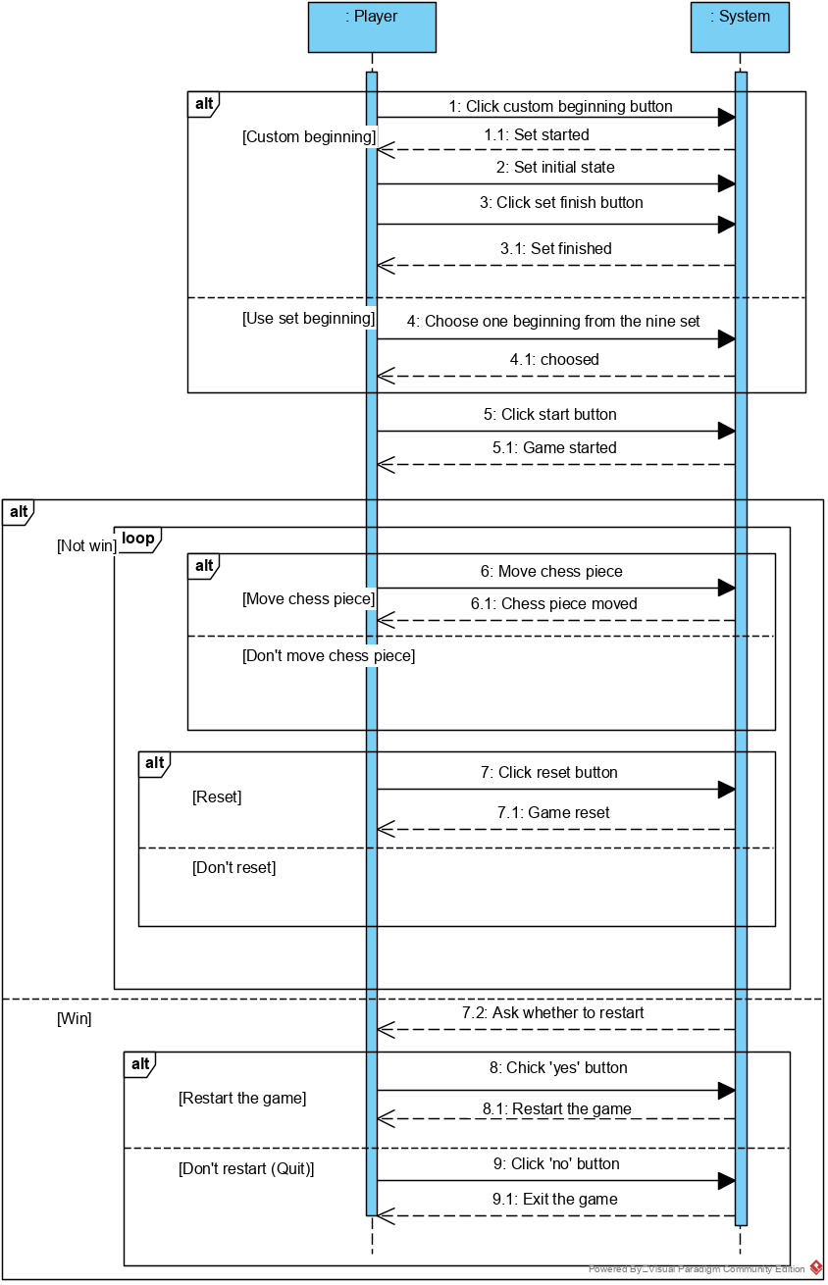

## Software Requirements

### R1: Game UI

* R1.1: The player should be able to play Huarong Path normally on the Game UI
  + R1.1.1: The player should be able to start the game
  + R1.1.2: The player should be able to choose one beginning of the game
  + R1.1.3: The player should be able to go back to the main menu
  + R1.1.4: The game status can be seen directly and update after moving chess piece
  + R1.1.5: The player should be able to choose chess piece
  + R1.1.6: The player should be able to move chess piece
  + R1.1.7: The player should be able to reset the game status
  + R1.1.8: The game should be able to record the steps
  + R1.1.9: The system should be able to determine whether the player wins
* R1.2: After winning, the player can replay the game or exit.
  + R1.2.1: The player can replay the game normally after winning
  + R1.2.2: The player can exit the game normally after winning
* R1.3: The player should be able to custom the beginning status as he wants.
  + R1.3.1: The player should be able to set the position of the given chess piece
  + R1.3.2: The beginning status can be seen directly and update after setting new chess piece
  + R1.3.3: The chess pieces cannot overlap.
  + R1.3.4: The player should be able to reset the beginning status
* R1.4: Actions that violate the game rules should be considered invalid
  + R1.4.1: The chess pieces cannot be moved outside the chess board
  + R1.4.2: The chess pieces cannot overlap while being moved
  + R1.4.3: Only one chess piece can be moved at a time
  + R1.4.4: A chess piece can only be moved one step at a time